Let's Defend President Gonzalo's Life!
Freedom for President Gonzalo and All Political Prisoners!

Information published by the revolutionary and progressive press and organisations primarily based in Latin America indicates that on July 20, 2021, comrade Abimael Guzman Reynoso, “Chairman Gonzalo” the leader of the Communist Party of Peru (PCP), was transferred to a hospital near the Callao Naval Base Maximum-Security Prison. The reactionary press claim that the comrade has advanced skin cancer. However, his lawyers reports that the senior comrade, now 89 years old, after 29 years of incarceration and isolation, has Psoriasis and that the disease is aggravated by his advanced age and the notably colder time of the year. Progressive and revolutionary individuals and organisations worldwide are increasingly raising their voice and extreme concern about the health and well-being of comrade Gonzalo and demand his freedom and respect for his rights as a political prisoner and a prisoner of war.
We join in solidarity and support other progressive and revolutionary forces, including those currently incarcerated in prisons in Peru, to condemn the torture and ill-treatment of comrade Gonzalo and demand his immediate freedom.
Dr Abimael Guzman has suffered 29 years of isolation in a grave-like prison underground as an ultimate form of torture, yet he has never lowered his clenched fist of resistance and continues with his struggle against imperialism and reaction exposing the reactionaries at every opportunity. He has frustrated the reactionary judicial system, the torturers and the jailers that deny even their own laws and the international conventions on the treatment of political prisoners and prisoners of war, exposing their class hatred of the proletariat and its representatives.
We have witnessed the notorious Alberto Fujimori the Peruvian butcher president from 1990 -2000 tried and sentenced to 25 years imprisonment for corruption, embezzlement, genocide, and other crimes against the people of Peru released from prison on humanitarian grounds.
Comrade Gonzalo led the PCP and launched the people’s war and liberation struggle in Peru in 1980 against the reactionary comprador state. The revolution advanced and was so successful that it had reached the centre of Lima, the capital of Peru by 1992. His leadership mobilised millions of the workers and the oppressed to take their lives into their own hands and dare to challenge and smash the old state as the representative of the imperialist capitalist system.
After his capture on September 12, 1992, when the criminal Fujimori regime and his henchman, Montesinos under CIA direction prepared to embarrass and humiliate the proletarian movement and the leaders of the People’s War in Peru, Comrade Gonzalo wearing the specially designed striped vest and locked up in a cage designed to exaggerate the drama of his captivity, in front of world media delivered his famous, September 24th speech, calling on his comrades at home and the international proletarian forces to continue on the path for struggle and resistance till liberation. The inspirational speech still reverberates across the world and continues to ring in our ears. It was immediately translated into all languages and was distributed across the globe.
It is well known that when captured, Gonzalo addressing his captors pointed to his head and said, "You can do whatever you want, even kill me. But you can't kill what's on my mind." Since his arrest on September 12, 1992, comrade Gonzalo’s revolutionary thoughts and views have continued to inspire and be the source of much discussion and discourse within the revolutionary movement far beyond Peru. Comrade Gonzalo is an exemplary symbol of resistance advancing the struggle against imperialism and reactionaries from behind prison bars.
We call on all progressive, democratic, revolutionary, and communists as individuals and organised forces to raise their voice in solidarity with the call to defend the life and health of comrade Gonzalo and to raise high the call for the freedom of Dr Abimael Guzman and all other political prisoners in Peru.

Let's Defend President Gonzalo's Life
Freedom for President Gonzalo and all Political Prisoners!
Down with the Peruvian State and US Imperialism
Long Live International Solidarity
Long live Marxism Leninism Maoism

Communist Party of Turkey – Marxist Leninist (TKP-ML)
International Bureau
August 2021

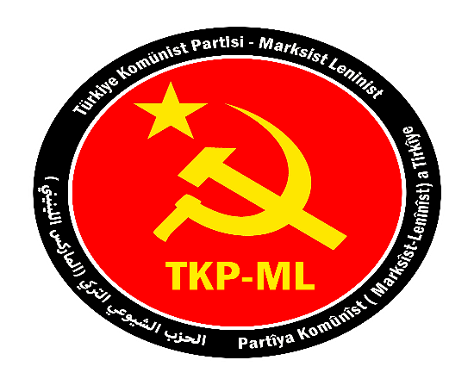

Link: https://www.tkpml.com/tkp-ml-international-bureau-lets-defend-president-gonzalos-life/

